In the Name of God



Navid Zare

40435071

Statistical Pattern Recognition
Bayesian Classification & Dimensionality Reduction

1. Introduction
This report presents a comprehensive study of two fundamental topics in statistical pattern recognition: binary classification using Bayesian classifiers and dimensionality reduction using Principal Component Analysis (PCA) and Fisher Linear Discriminant Analysis (Fisher LDA). The primary objective is to develop a thorough understanding of the theoretical foundations of these algorithms, implement them from scratch using only numerical computing libraries, and perform rigorous statistical and conceptual analyses of the results.
The first part of this work addresses binary classification on the Breast Cancer Wisconsin (Diagnostic) dataset using three generative Bayesian classifiers: Gaussian Naive Bayes (GNB), Linear Discriminant Analysis (LDA), and Quadratic Discriminant Analysis (QDA). These classifiers differ in their assumptions about the class-conditional covariance structure, which directly affects decision boundary geometry and model complexity. A detailed analysis of covariance matrix conditioning, variance-based feature selection, and classification performance is conducted.
The second part investigates dimensionality reduction techniques applied to the ORL face database for face recognition. PCA is employed as an unsupervised method to identify directions of maximum variance, while Fisher LDA is utilized as a supervised technique to maximize class separability. The interplay between dimensionality reduction and classification accuracy is examined across varying numbers of retained components.

2. Part 1: Binary Classification Using Bayesian Classifiers

2.1 Understanding the Data

2.1.1 Dataset Overview
The Breast Cancer Wisconsin (Diagnostic) dataset was loaded and inspected. It comprises 569 samples described by 30 continuous numerical features extracted from digitized images of fine needle aspirate (FNA) of breast masses. Each sample is labeled as either Malignant (M) or Benign (B), constituting a binary classification problem. The features capture ten real-valued characteristics (radius, texture, perimeter, area, smoothness, compactness, concavity, concave points, symmetry, and fractal dimension), each computed as the mean, standard error, and worst (largest) value across the cell nuclei present in the image.
Property | Value
Number of Samples | 569
Number of Features | 30
Number of Classes | 2 (M, B)
Benign Samples | 357 (62.74%)
Malignant Samples | 212 (37.26%)
Table 1: Breast Cancer Wisconsin dataset summary statistics.

2.1.2 Class Distribution and Imbalance
The class distribution reveals a moderate imbalance with a ratio of approximately 1.68:1 in favor of the benign class. While this imbalance is not extreme, it has meaningful implications for Bayesian classifiers. The class prior probabilities, which enter directly into the posterior computation via Bayes’ rule, will reflect this imbalance. In particular, the classifier may be biased toward predicting the majority class (Benign) in ambiguous cases, potentially reducing recall for the malignant class. This is an important consideration in a medical diagnostic context where failing to detect malignancy (false negative) carries significant clinical consequences.

2.1.3 Exploratory Visual Analysis
Class-wise histograms were plotted for a subset of features to assess the distributional characteristics of each class. As shown in Figure 1, features such as mean radius, mean concavity, and worst area exhibit clear separation between the benign and malignant distributions, suggesting strong discriminative power. Other features display more overlapping distributions, indicating lower individual classification utility.
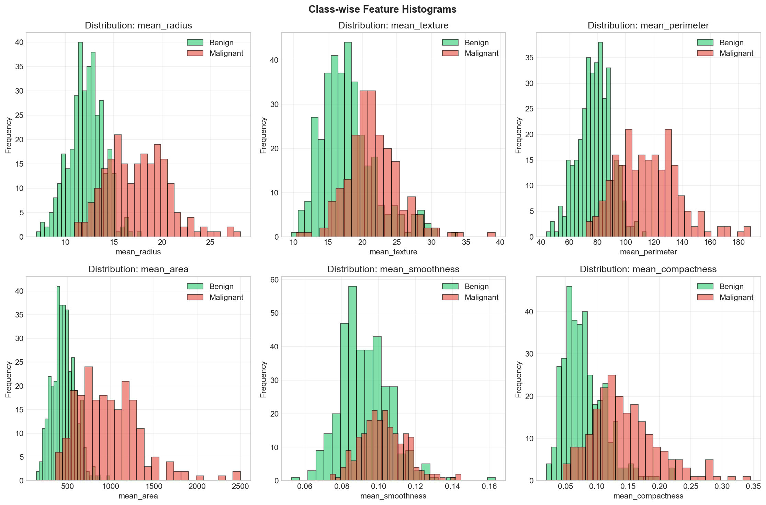
Figure 1: Class-wise histograms for selected features showing distributional separation between benign and malignant classes.
The feature correlation matrix, visualized as a heatmap in Figure 2, reveals substantial inter-feature correlations, particularly among geometric features (radius, perimeter, area) within the same statistical category (mean, standard error, worst).
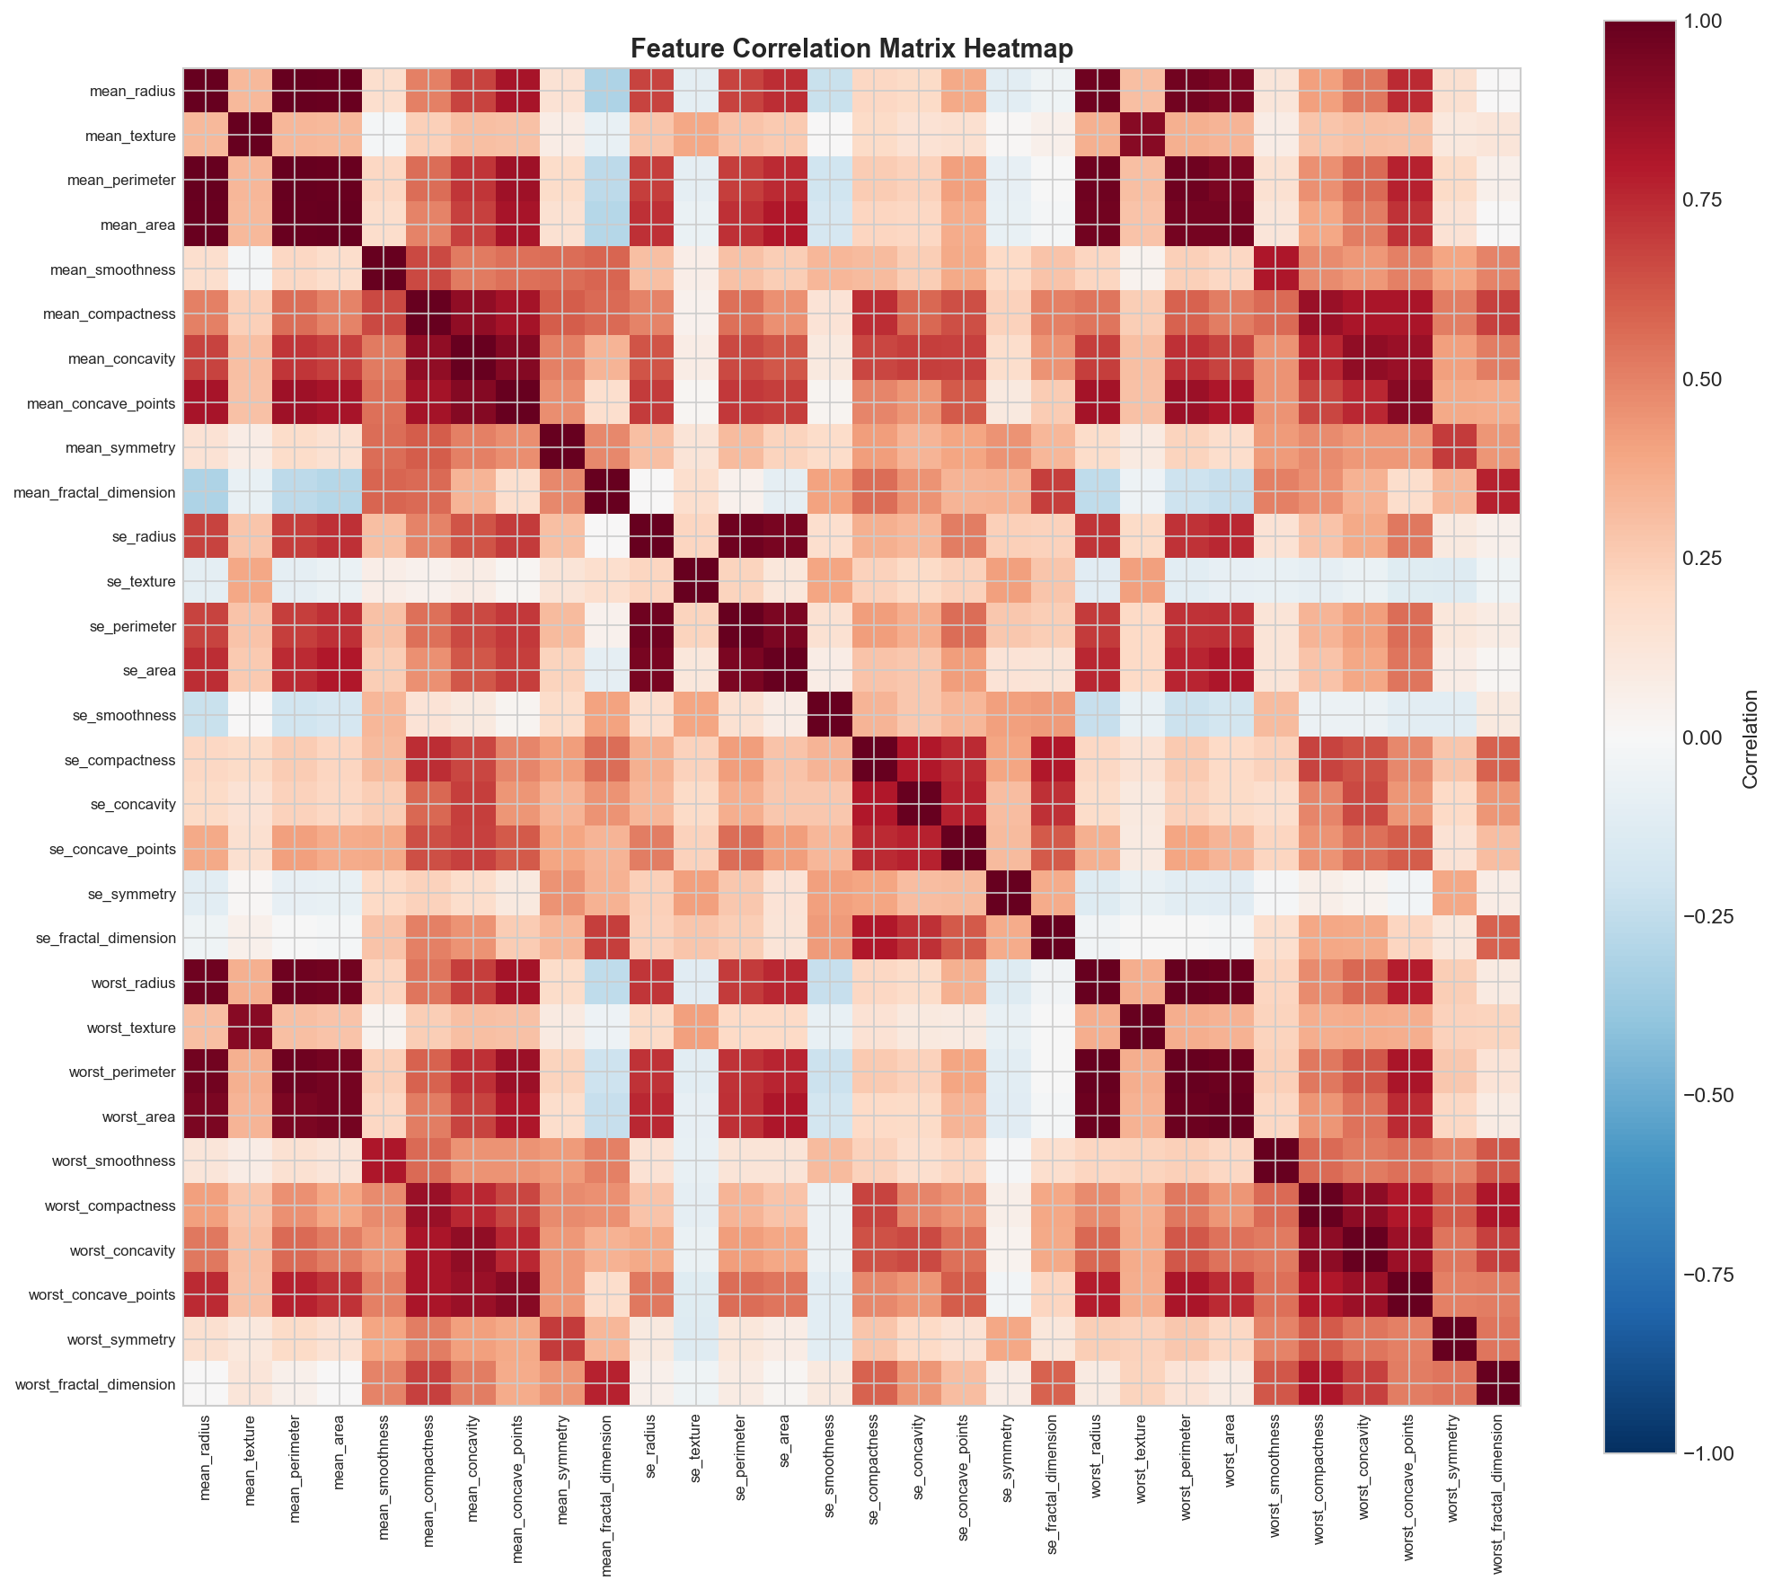
Figure 2: Feature correlation heatmap revealing strong inter-feature dependencies.

2.1.4 Highly Correlated Feature Pairs
The three most highly correlated feature pairs were identified as follows:
Rank | Feature 1 | Feature 2 | |Correlation|
1 | mean_radius | mean_perimeter | 0.9979
2 | worst_radius | worst_perimeter | 0.9937
3 | mean_radius | mean_area | 0.9874
Table 2: Three most highly correlated feature pairs.
High feature correlation is critical when comparing LDA and QDA with Naive Bayes. Gaussian Naive Bayes assumes conditional independence of features given the class, thereby modeling only diagonal covariance matrices. When features are strongly correlated, this assumption is violated, and GNB cannot capture the joint distributional structure. In contrast, LDA and QDA model the full covariance matrix (shared or class-specific, respectively) and can therefore represent and exploit feature correlations in the decision boundary. The near-perfect correlations observed (e.g., 0.9979 between mean_radius and mean_perimeter) indicate substantial redundancy that GNB fundamentally ignores.

2.1.5 Gaussianity of Feature Distributions
Visual inspection of the class-wise histograms reveals that many features approximate Gaussian distributions, though some exhibit skewness (e.g., area-related features) or multimodality. Despite these deviations, Gaussian-based Bayesian classifiers remain widely used for several reasons. First, the central limit theorem provides theoretical justification when features are aggregated statistics. Second, Bayesian classifiers are relatively robust to moderate deviations from Gaussianity, particularly when the decision boundary is primarily determined by the first and second moments (mean and covariance). Third, the analytical tractability of the Gaussian assumption enables closed-form parameter estimation and efficient classification.
Deviations from Gaussianity affect LDA and QDA differently. LDA, which assumes a shared covariance matrix across classes, is primarily sensitive to departures that alter the location of the linear decision boundary. QDA, which allows class-specific covariance matrices, is more sensitive to distributional shape within each class, as the quadratic boundary depends on the full covariance structure. When within-class distributions deviate significantly from Gaussianity, QDA’s additional flexibility may not translate into improved performance and could instead lead to overfitting.

2.2 Bayesian Decision Theory and Distance Measures

2.2.1 Bayes’ Rule
Bayes’ rule provides the mathematical foundation for probabilistic classification. For a feature vector x and class label y, the posterior probability is given by:
$$P\left(y | x\right)=\frac{P\left(x | y\right)⋅P\left(y\right)}{P\left(x\right)}$$
where P(y) is the prior probability reflecting the relative frequency of class y in the training data, $P\left(x | y\right)$is the class-conditional likelihood describing how the features are distributed within each class, and $P\left(y | x\right)$is the posterior probability of class membership given the observed features. The normalizing constant P(x) ensures that the posterior sums to one across classes. For classification, it is sufficient to maximize the unnormalized posterior$P\left(x | y\right)⋅P\left(y\right)$, since P(x) is identical for all classes and does not affect the argmax decision.

2.2.2 Mahalanobis Distance
The Mahalanobis distance generalizes the Euclidean distance by accounting for feature correlations and scaling. For a point x relative to a mean μ with covariance matrix Σ, it is defined as:
$$d_{M}\left(x,μ\right)=\sqrt{{\left(x-μ\right)}^{⊤}Σ^{-1}\left(x-μ\right)}$$
Unlike Euclidean distance, which treats all directions equally, the Mahalanobis distance weights directions according to the inverse covariance, effectively measuring distance in units of standard deviations along the principal axes of the data distribution. This distance naturally appears in the log-likelihood of multivariate Gaussian distributions and is therefore central to both LDA and QDA. In GNB, because the covariance matrix is constrained to be diagonal, the distance reduces to a weighted sum of squared differences along individual feature axes, which is a special case that does not explicitly involve the full Mahalanobis formulation.

2.3 Model Parameters

2.3.1 Parameter Identification
Gaussian Naive Bayes requires per-class priors π_k, per-class per-feature means${ μ}_{k,j}$, and per-class per-feature variances $σ_{k,j}^{2}$. For K classes and D features, this totals K + 2KD parameters. With K=2 and D=30, GNB requires 122 parameters.
LDA requires per-class priors π_k, per-class mean vectors $μ_{k}$(each of dimension D), and a single shared covariance matrix Σ of dimension D×D. Accounting for symmetry, the shared covariance contributes $\frac{D\left(D+1\right)}{2}$ unique parameters. The total is $K+KD+\frac{D\left(D+1\right)}{2}=2+60+465=527$parameters.
QDA requires per-class priors, per-class mean vectors, and class-specific covariance matrices $Σ_{k}$. The total is $K+KD+K⋅\frac{D\left(D+1\right)}{2}=2+60+930=992$parameters.

2.3.2 Complexity Comparison
Aspect | GNB | LDA | QDA
Free Parameters | 122 | 527 | 992
Covariance | Diagonal | Shared Full | Class-Specific
Decision Boundary | Nonlinear* | Linear | Quadratic
Flexibility | Low | Moderate | High
Table 3: Comparison of model parameters and complexity across classifiers. *GNB produces nonlinear boundaries due to independent feature treatment.
QDA, with 992 free parameters, requires the most training data for reliable estimation. Given the dataset has only 212 malignant samples (the minority class), estimating a 30×30 class-specific covariance matrix from approximately 170 training samples per minority class is statistically challenging. This raises concerns about covariance estimation stability and potential overfitting, particularly for QDA.

2.4 Model Implementation and Classification

2.4.1 Train-Test Split
The dataset was split into 80% training (456 samples) and 20% testing (113 samples) using stratified sampling to preserve the class distribution in both subsets. This ensures that the class imbalance ratio is maintained across partitions and prevents biased evaluation.

2.4.2 Parameter Estimation
All three classifiers were implemented from scratch using NumPy. The estimated class priors for both the benign and malignant classes were [0.627, 0.373], consistent with the observed class distribution. For GNB, feature-wise means and variances were estimated per class. For LDA, a pooled (shared) covariance matrix was computed by aggregating within-class scatter matrices, normalized by (n-1). For QDA, separate covariance matrices were computed for each class. A small regularization term (εI with ε = 10⁻⁴ for QDA and 10⁻⁶ for LDA) was added to the covariance diagonal to improve numerical stability of matrix inversion.

2.4.3 Covariance Structure and Decision Boundaries
The covariance structure fundamentally determines the geometry of the decision boundary. GNB’s diagonal covariance produces axis-aligned ellipsoidal class regions in feature space, yielding decision boundaries that are products of independent per-feature decisions. LDA’s shared full covariance produces linear (hyperplanar) decision boundaries, as the quadratic terms in the log-posterior cancel when the covariance is identical across classes. QDA’s class-specific covariances retain the quadratic terms, producing curved (quadric) decision surfaces that can capture more complex class-conditional structures.

2.4.4 Classification Results
All three classifiers were applied to both training and test sets. The results are summarized in Table 4.
Classifier | Set | Accuracy | Precision | Recall | F1
GNB | Train | 0.9364 | 0.9273 | 0.9000 | 0.9134
GNB | Test | 0.9115 | 0.8810 | 0.8810 | 0.8810
LDA | Train | 0.9715 | 1.0000 | 0.9235 | 0.9602
LDA | Test | 0.9381 | 0.9487 | 0.8810 | 0.9136
QDA | Train | 0.9715 | 0.9876 | 0.9353 | 0.9607
QDA | Test | 0.9381 | 0.9070 | 0.9286 | 0.9176
Table 4: Classification performance metrics for all three Bayesian classifiers on training and test sets.

2.4.5 Numerical Stability of QDA
Despite the relatively high dimensionality (30 features) relative to the number of per-class training samples (approximately 170 for malignant), QDA performs comparably to LDA on this dataset. The regularization term added to the class-specific covariance matrices ensures that the matrices remain positive definite and invertible. Without regularization, the 30×30 covariance matrices estimated from limited samples could become ill-conditioned or singular, leading to numerically unstable discriminant values. The fact that QDA achieves identical training accuracy to LDA (97.15%) and comparable test performance suggests that the regularization effectively mitigates estimation instability.

2.4.6 Analysis of GNB as a Baseline
GNB achieves a test accuracy of 91.15%, which is lower than both LDA (93.81%) and QDA (93.81%). This performance gap is attributable to the conditional independence assumption, which prevents GNB from exploiting the strong feature correlations present in the data (as demonstrated by correlation coefficients exceeding 0.99). The class prior probabilities (0.627 for Benign, 0.373 for Malignant) influence GNB’s predictions by introducing a bias toward the majority class, which partially explains the balanced but lower recall for both classes. Despite its simplicity, GNB serves as a useful baseline, establishing a lower bound on performance achievable without full covariance modeling.

2.5 Covariance Matrix Analysis

2.5.1 Rank and Singularity
The empirical covariance matrix of the training feature matrix X (30×30) was computed using only the training data. The matrix was found to have full rank (30), indicating that it is non-singular and theoretically invertible. However, full rank does not guarantee numerical stability in practice. When the ratio between the largest and smallest eigenvalues is extremely large, even small perturbations (e.g., from finite-precision arithmetic) can cause large errors in the inverse, rendering the matrix effectively ill-conditioned despite being mathematically invertible.

2.5.2 Eigenvalue Analysis
The eigenvalue decomposition of the covariance matrix revealed a dramatic spread in the eigenvalue spectrum. As shown in Figure 3, the largest eigenvalue is approximately 4.59×10⁵ while the smallest is approximately 7.43×10⁻⁷, spanning roughly 12 orders of magnitude.
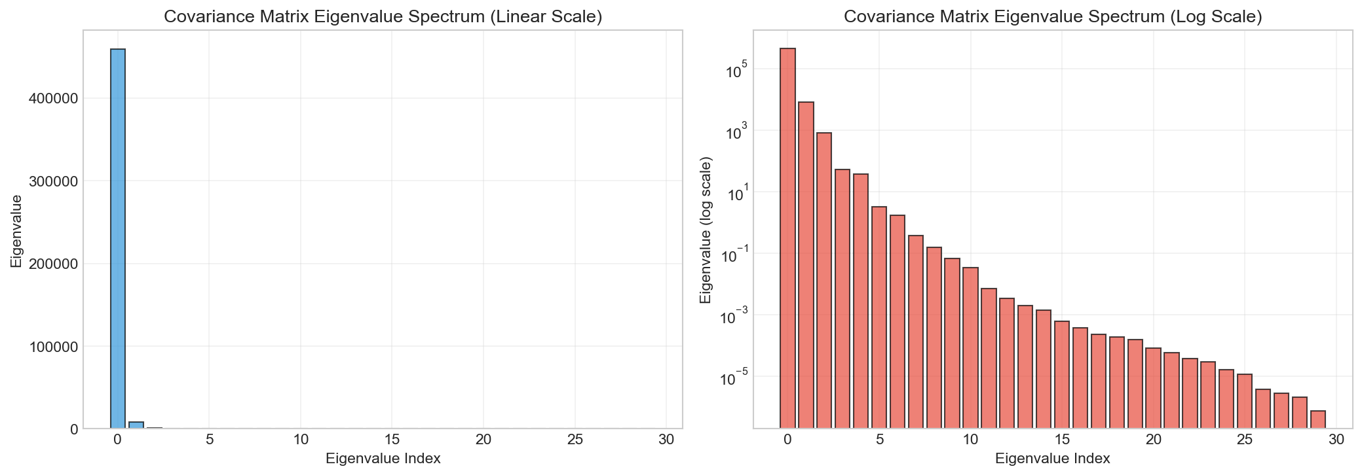
Figure 3: Eigenvalue spectrum of the training covariance matrix showing extreme spread across magnitudes.

2.5.3 Condition Number
The condition number of the covariance matrix is 6.18×10¹¹, which is extremely high. The condition number, defined as the ratio of the largest to smallest eigenvalue for symmetric positive definite matrices, quantifies the sensitivity of matrix inversion to perturbations. A condition number of this magnitude means that numerical errors in representing the covariance entries can be amplified by a factor of approximately 10¹¹ during inversion. For standard double-precision floating-point arithmetic (approximately 16 significant digits), this leaves only about 5 reliable digits in the inverse, which can materially affect the Mahalanobis distance computation and, consequently, classification decisions.

2.5.4 Singular vs. Ill-Conditioned Matrices
It is essential to distinguish between singular and ill-conditioned covariance matrices. A singular matrix has at least one zero eigenvalue and is not invertible. An ill-conditioned matrix is invertible but has eigenvalues spanning an extremely wide range, making the inverse numerically unreliable. The covariance matrix in this dataset is full-rank (non-singular) yet severely ill-conditioned (condition number of 6.18×10¹¹). This situation arises because features operate on vastly different scales (e.g., area features with variances on the order of 10⁴ versus fractal dimension features with variances on the order of 10⁻⁶). The practical implication is that while the matrix inverse exists mathematically, its computed version may be inaccurate, necessitating regularization.

2.6 Variance Analysis and Feature Contribution
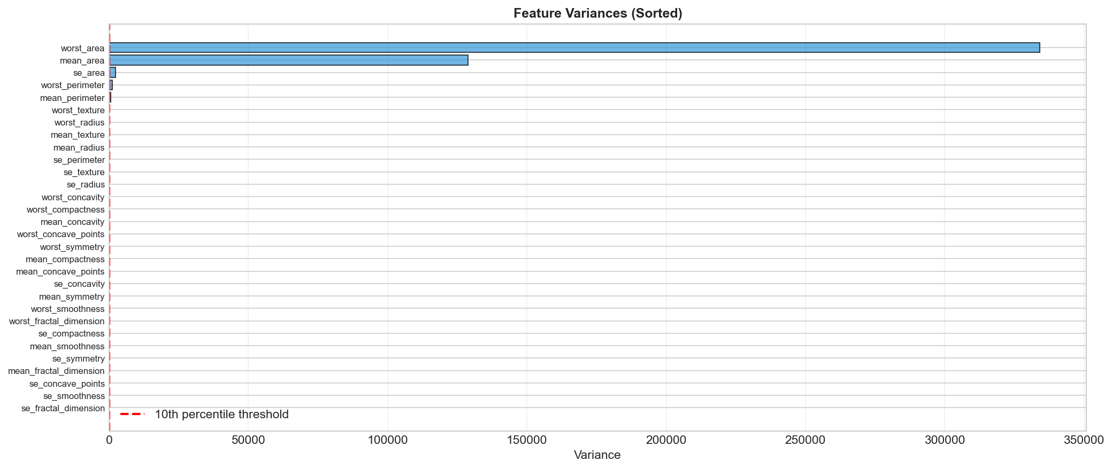
The variance of each feature was computed from the training data and ranked in ascending order. Figure 4 displays the feature variances on a logarithmic scale, revealing a range spanning many orders of magnitude.

Figure 4: Feature variances (log scale) showing the extreme range across features.
The bottom 10 features by variance are listed in Table 5, with the three lowest-variance features falling below the 10th percentile threshold (4.92×10⁻⁵).
Feature | Variance
se_fractal_dimension | 7.62 × 10⁻⁶
se_smoothness | 9.52 × 10⁻⁶
se_concave_points | 4.00 × 10⁻⁵
mean_fractal_dimension | 5.02 × 10⁻⁵
se_symmetry | 6.25 × 10⁻⁵
Table 5: Five lowest-variance features in the training dataset.
The presence of low-variance features does not necessarily imply covariance matrix singularity. A feature with low but non-zero variance still contributes a non-zero diagonal entry to the covariance matrix, which can maintain full rank. However, low-variance features combined with correlations to other features can produce near-zero eigenvalues in the covariance matrix, even when all diagonal entries are non-zero. This occurs because the determinant (and smallest eigenvalue) depends on the full matrix structure, not just the diagonal. In this dataset, the extremely small eigenvalue (7.43×10⁻⁷) likely arises from near-linear dependencies among features with already small variances, which jointly create a near-singular direction in feature space.

2.7 Variance-Based Feature Elimination
Features with variance below the 10th percentile threshold (4.92×10⁻⁵) were identified and removed. Three features were eliminated: se_smoothness, se_concave_points, and se_fractal_dimension. The resulting reduced feature set contains 27 features.

2.7.1 Covariance Analysis Comparison
Metric | Before (30) | After (27)
Rank | 30 | 27
Condition Number | 6.18 × 10¹¹ | 1.61 × 10¹¹
Min Eigenvalue | 7.43 × 10⁻⁷ | 2.86 × 10⁻⁶
Max Eigenvalue | 4.59 × 10⁵ | 4.59 × 10⁵
Table 6: Covariance matrix properties before and after variance-based feature elimination.
Removing the three lowest-variance features improved the condition number from 6.18×10¹¹ to 1.61×10¹¹ and increased the minimum eigenvalue by approximately a factor of four. However, the condition number remains extremely high (on the order of 10¹¹), indicating that variance-based feature elimination alone is insufficient to resolve the ill-conditioning problem. This is because the dominant source of ill-conditioning is the extreme scale disparity among retained features (e.g., area features versus smoothness features), which cannot be addressed by removing only the lowest-variance features. More effective remedies include feature standardization or Tikhonov regularization of the covariance matrix.

2.8 Re-Estimation with Reduced Features
LDA and QDA were re-trained on the 27-feature reduced dataset. The classification results are presented in Table 7.
Classifier | Set | Accuracy | Precision | Recall | F1
LDA (27) | Train | 0.9693 | 1.0000 | 0.9176 | 0.9571
LDA (27) | Test | 0.9292 | 0.9474 | 0.8571 | 0.9000
QDA (27) | Train | 0.9715 | 0.9876 | 0.9353 | 0.9607
QDA (27) | Test | 0.9292 | 0.9048 | 0.9048 | 0.9048
Table 7: Classification performance after variance-based feature elimination (27 features).
Removing the three low-variance features resulted in a slight decrease in test accuracy for both LDA (from 93.81% to 92.92%) and QDA (from 93.81% to 92.92%). This marginal degradation suggests that the removed features, despite their low variance, did carry some discriminative information. The training performance remained nearly unchanged, indicating that the model’s capacity to fit the training data was not materially affected. These results confirm that variance is not a reliable proxy for discriminative relevance; a feature with low variance can still be informative if its distribution differs systematically between classes.

2.9 Performance Evaluation and Error Analysis

2.9.1 Comprehensive Performance Summary
Table 8 consolidates all classification results across the five model configurations evaluated.

Classifier | Set | Acc | Prec | Recall | F1
GNB | Train | 0.9364 | 0.9273 | 0.9000 | 0.9134
GNB | Test | 0.9115 | 0.8810 | 0.8810 | 0.8810
LDA | Train | 0.9715 | 1.0000 | 0.9235 | 0.9602
LDA | Test | 0.9381 | 0.9487 | 0.8810 | 0.9136
QDA | Train | 0.9715 | 0.9876 | 0.9353 | 0.9607
QDA | Test | 0.9381 | 0.9070 | 0.9286 | 0.9176
LDA (27) | Train | 0.9693 | 1.0000 | 0.9176 | 0.9571
LDA (27) | Test | 0.9292 | 0.9474 | 0.8571 | 0.9000
QDA (27) | Train | 0.9715 | 0.9876 | 0.9353 | 0.9607
QDA (27) | Test | 0.9292 | 0.9048 | 0.9048 | 0.9048
Table 8: Comprehensive performance comparison across all classifier configurations.

2.9.2 Error Analysis
The confusion matrices for LDA and QDA on the test set are presented in Figures 5 and 6. The error analysis reveals the following pattern:
Classifier | Total Errors | FP | FN
LDA | 7 | 2 | 5
QDA | 7 | 4 | 3
LDA (27) | 8 | 2 | 6
QDA (27) | 8 | 4 | 4
Table 9: Error analysis on the test set.
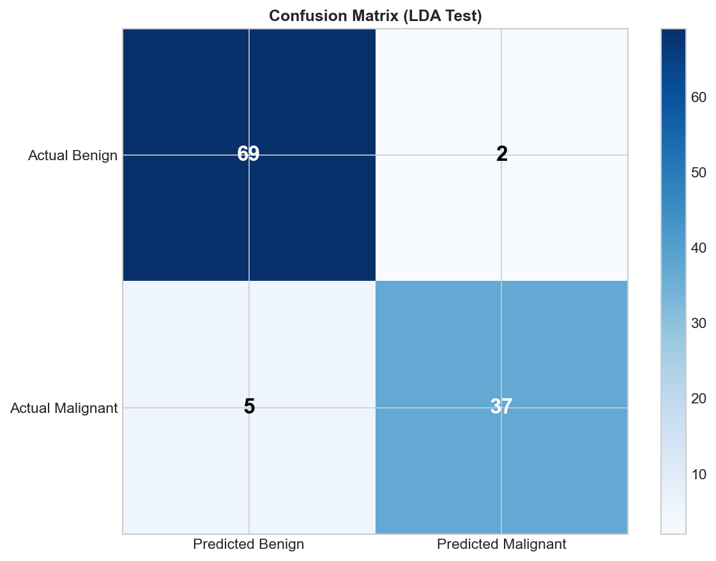
Figure 5: Confusion matrix for LDA on the test set.
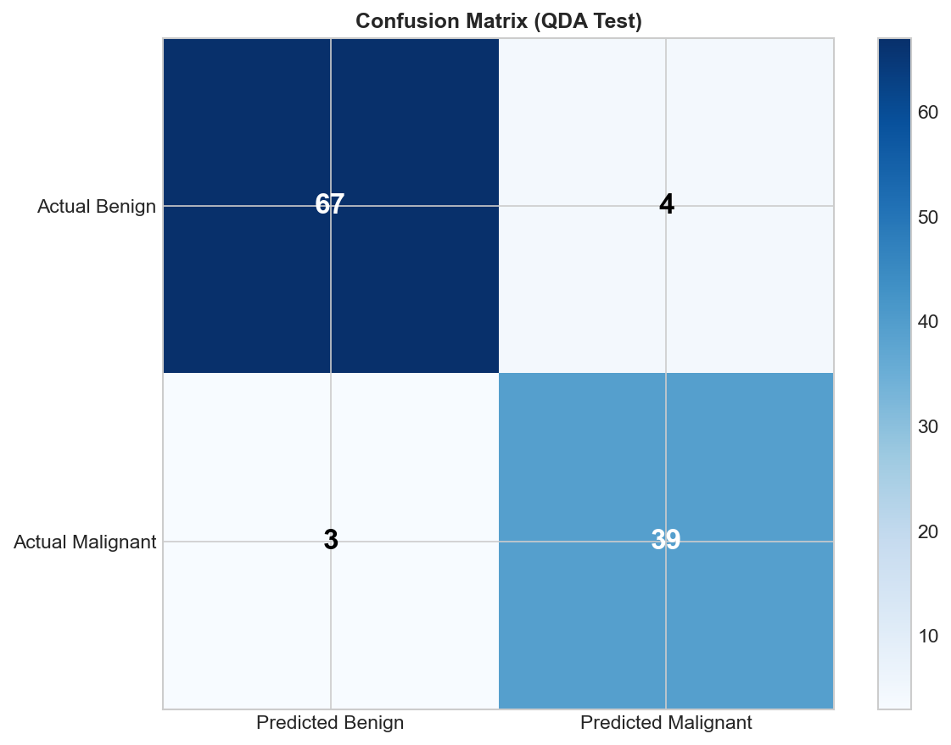
Figure 6: Confusion matrix for QDA on the test set.
LDA exhibits a higher proportion of false negatives (5 FN vs. 2 FP), meaning it is more likely to miss malignant cases. QDA distributes its errors more evenly (4 FP, 3 FN), achieving higher recall (0.9286) for the malignant class at the cost of slightly lower precision (0.9070). In a medical diagnostic setting, QDA’s error profile may be preferred because the cost of missing a malignant tumor (false negative) is typically far greater than the cost of a false alarm (false positive).
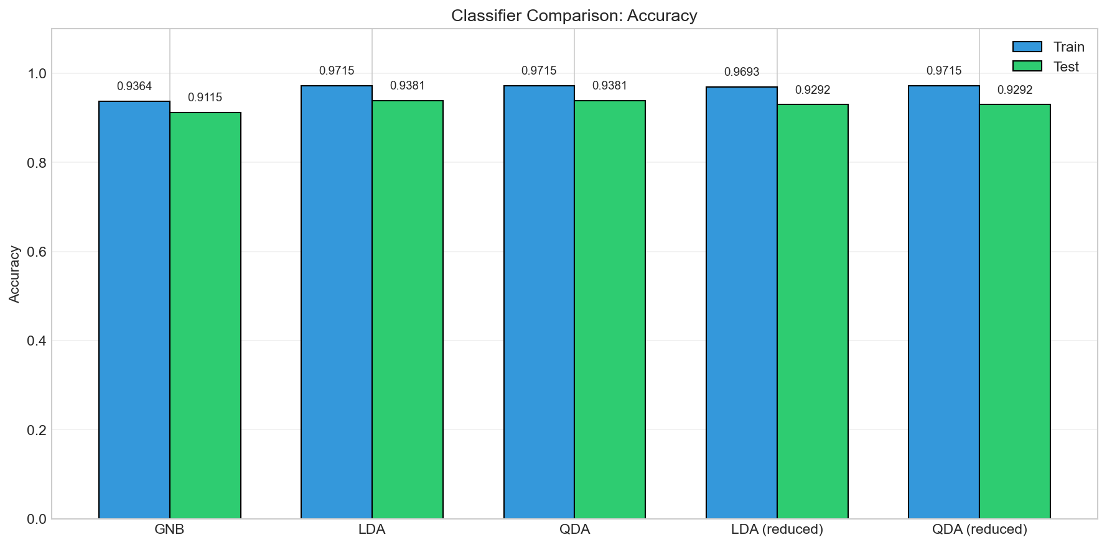
Figure 7: Classifier accuracy comparison across all configurations.

2.9.3 Generalization Analysis
Both LDA and QDA exhibit a train-test accuracy gap of 3.34 percentage points (train: 97.15%, test: 93.81%), suggesting mild overfitting. The identical gaps indicate that the additional flexibility of QDA (class-specific covariance) does not lead to additional overfitting compared to LDA on this dataset, likely due to the regularization applied during estimation. The relatively small generalization gap for both models confirms that 30 features with 456 training samples provides sufficient data for reasonable generalization, particularly given the regularization employed.

2.10 Model Parameters and Complexity Comparison
LDA requires 527 free parameters (2 priors + 60 mean entries + 465 unique covariance entries), while QDA requires 992 parameters (2 priors + 60 mean entries + 930 unique covariance entries across two matrices). QDA’s parameter count is approximately 1.88 times that of LDA. Despite this increased complexity, QDA does not demonstrate superior test accuracy on this dataset, consistent with the theoretical expectation that more flexible models require more data to realize their advantage. The nearly identical test accuracies (93.81%) suggest that the true class-conditional covariance structures are sufficiently similar that LDA’s shared covariance assumption is not overly restrictive, and QDA’s additional flexibility is not needed.

3. Part 2: Dimensionality Reduction

3.1 Dataset: The ORL Face Database
The ORL (Olivetti Research Laboratory) face database contains 400 grayscale images of 40 distinct subjects, with 10 images per subject. Each image has a resolution of 112×92 pixels, yielding 10,304-dimensional feature vectors when flattened. The images were taken under varying conditions of lighting, facial expression, and facial details (presence or absence of glasses), providing natural intra-class variation suitable for evaluating recognition systems.

3.2 Principal Component Analysis (PCA)

3.2.1 Data Preprocessing
All images were loaded, flattened to 10,304-dimensional vectors, and organized into a data matrix X of shape 400×10,304. The mean face was computed as the element-wise average across all 400 images and is visualized in Figure 8. Mean subtraction was applied to center the data, which is a prerequisite for PCA as it ensures that the principal components capture directions of maximum variance rather than being influenced by the global offset.
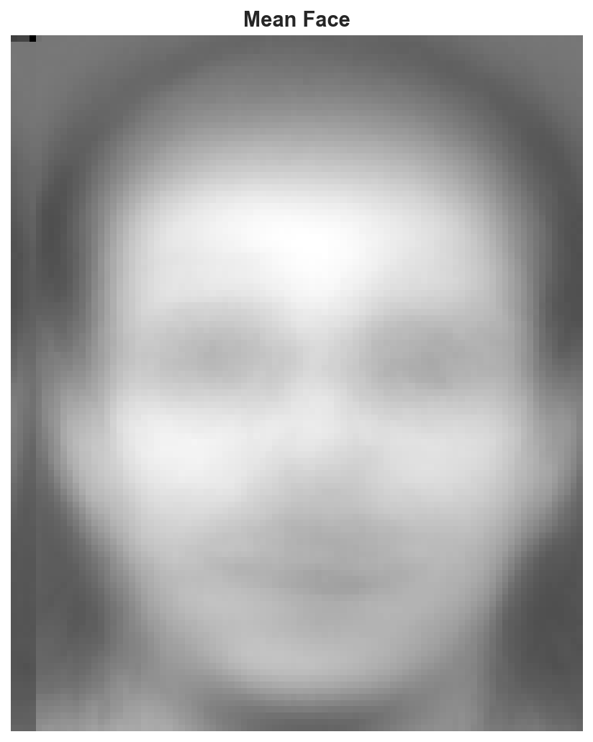
Figure 8: Mean face computed from the ORL database.
Figure 9 shows randomly selected original faces alongside their mean-subtracted counterparts. The mean-subtracted images represent the residual variation from the average face, which forms the basis for eigenface computation.
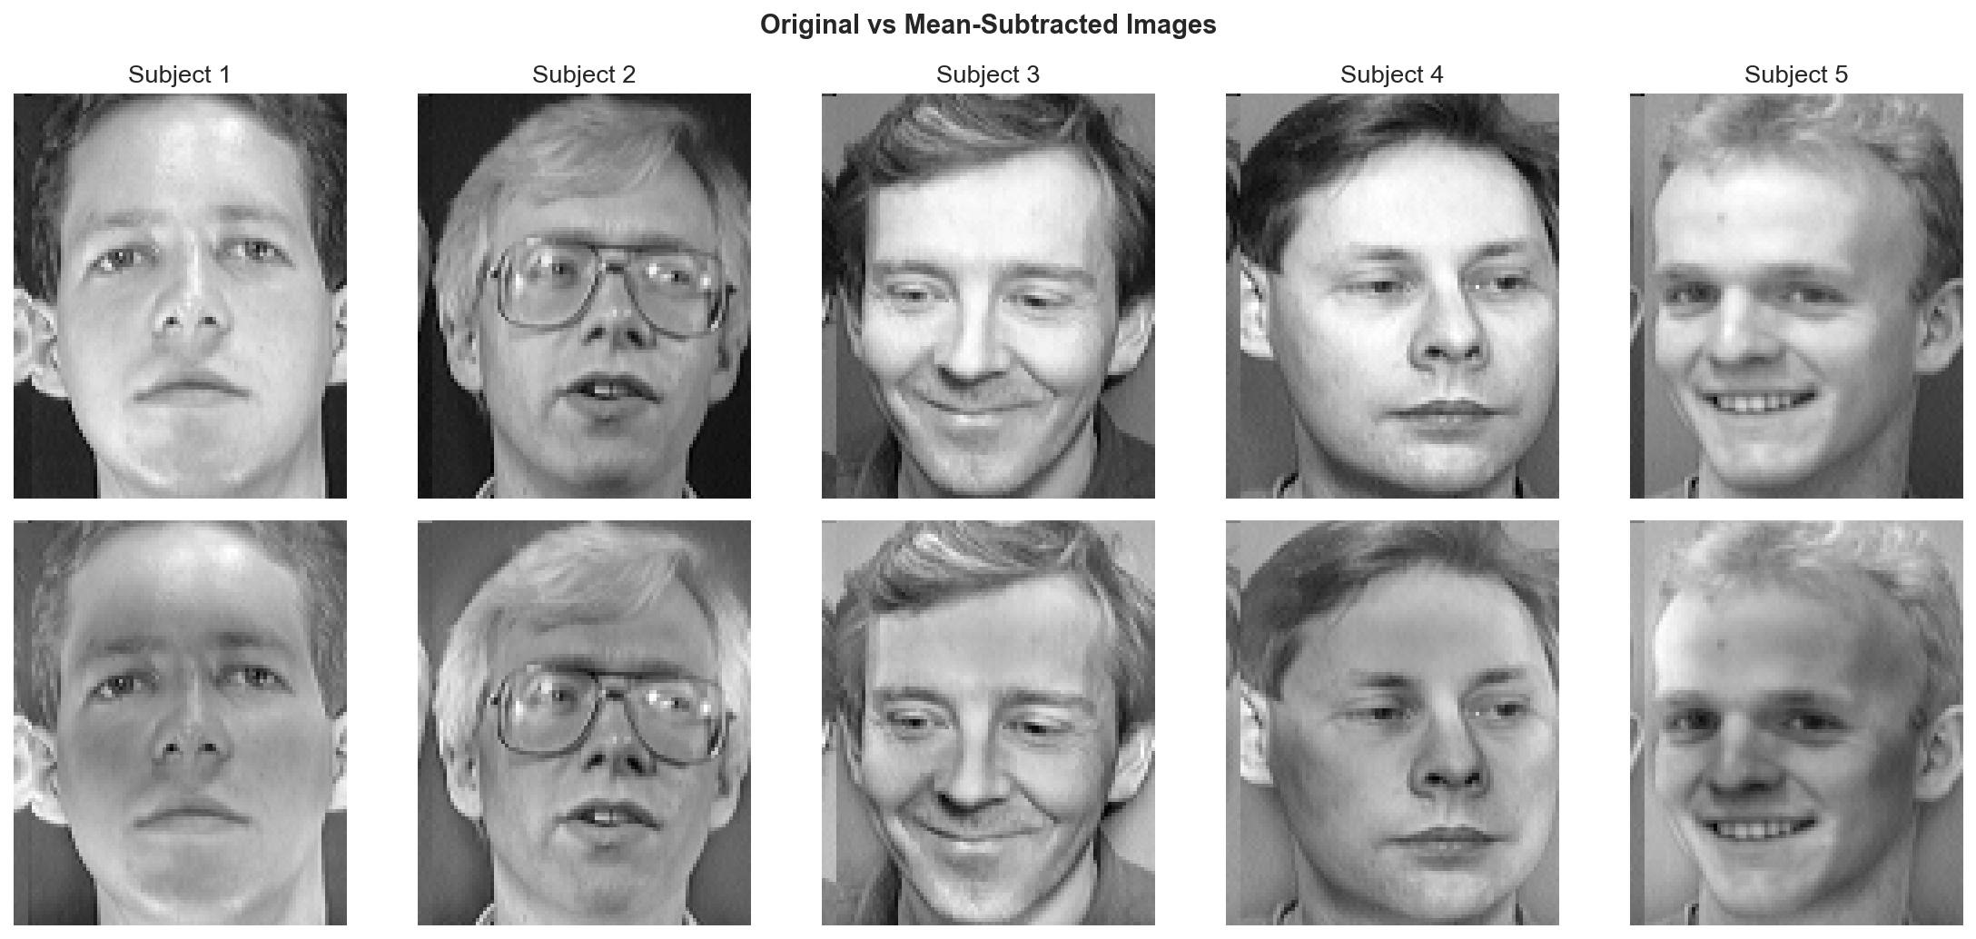
Figure 9: Original images (top row) versus mean-subtracted images (bottom row).
Two normalization strategies were considered: mean subtraction only and full standardization (unit variance scaling). Mean subtraction alone preserves the natural variance structure of pixel intensities, which is desirable for face recognition since pixels with higher variance (e.g., around the eyes, mouth) tend to carry more discriminative information. Standardization equalizes all pixel variances, which can suppress informative variation and was therefore not adopted.

3.2.2 PCA Implementation
Since the dimensionality (10,304) greatly exceeds the number of samples (400), the standard covariance matrix XᵀX would be impractically large (10,304×10,304). Instead, the algebraic PCA trick was employed: the smaller 400×400 matrix XXᵀ was computed, its eigenvectors were found, and these were transformed back to the original space via $X^{⊤}u$to obtain the principal components. This approach yields identical results while operating in the computationally feasible sample-dimensional space.
The eigenvalue decomposition yielded 400 principal components. Figure 10 shows the eigenvalue distribution and cumulative explained variance ratio. The rapid decay of eigenvalues indicates that a small number of components capture the majority of the data variance.
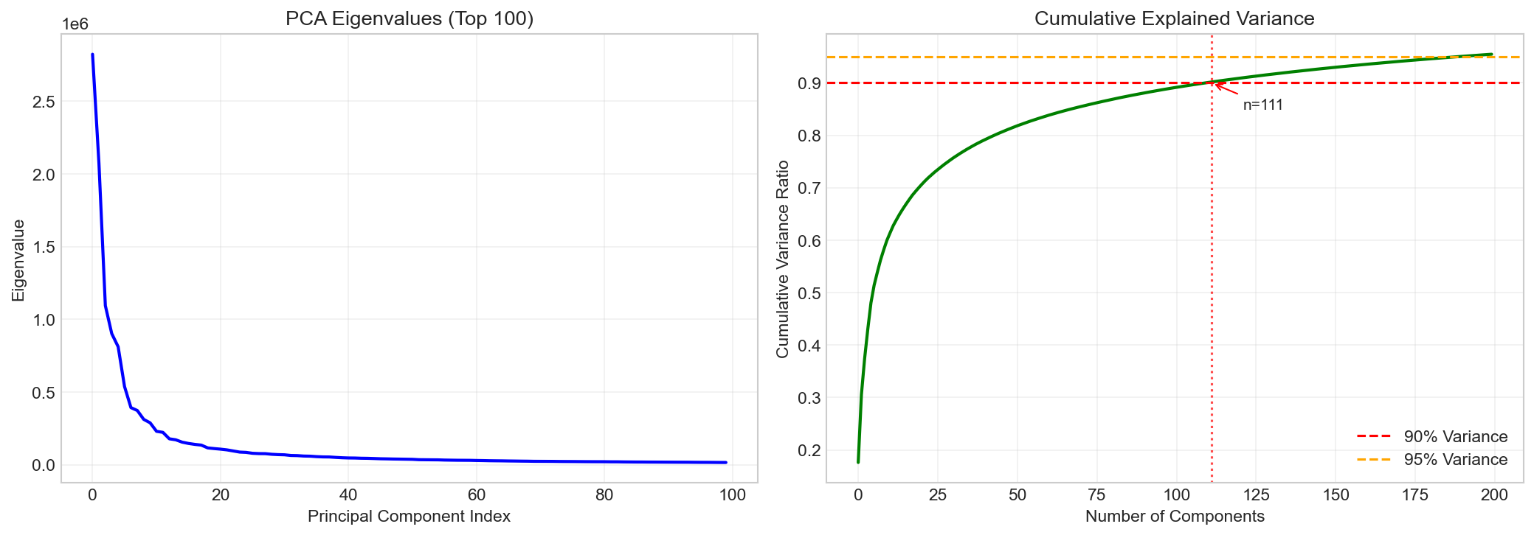
Figure 10: PCA eigenvalue distribution and cumulative explained variance.
The top 50 eigenfaces (principal components reshaped to image dimensions) are visualized in Figure 11. The first eigenfaces capture global illumination and face shape variations, while later eigenfaces represent progressively finer textural and local structural details.
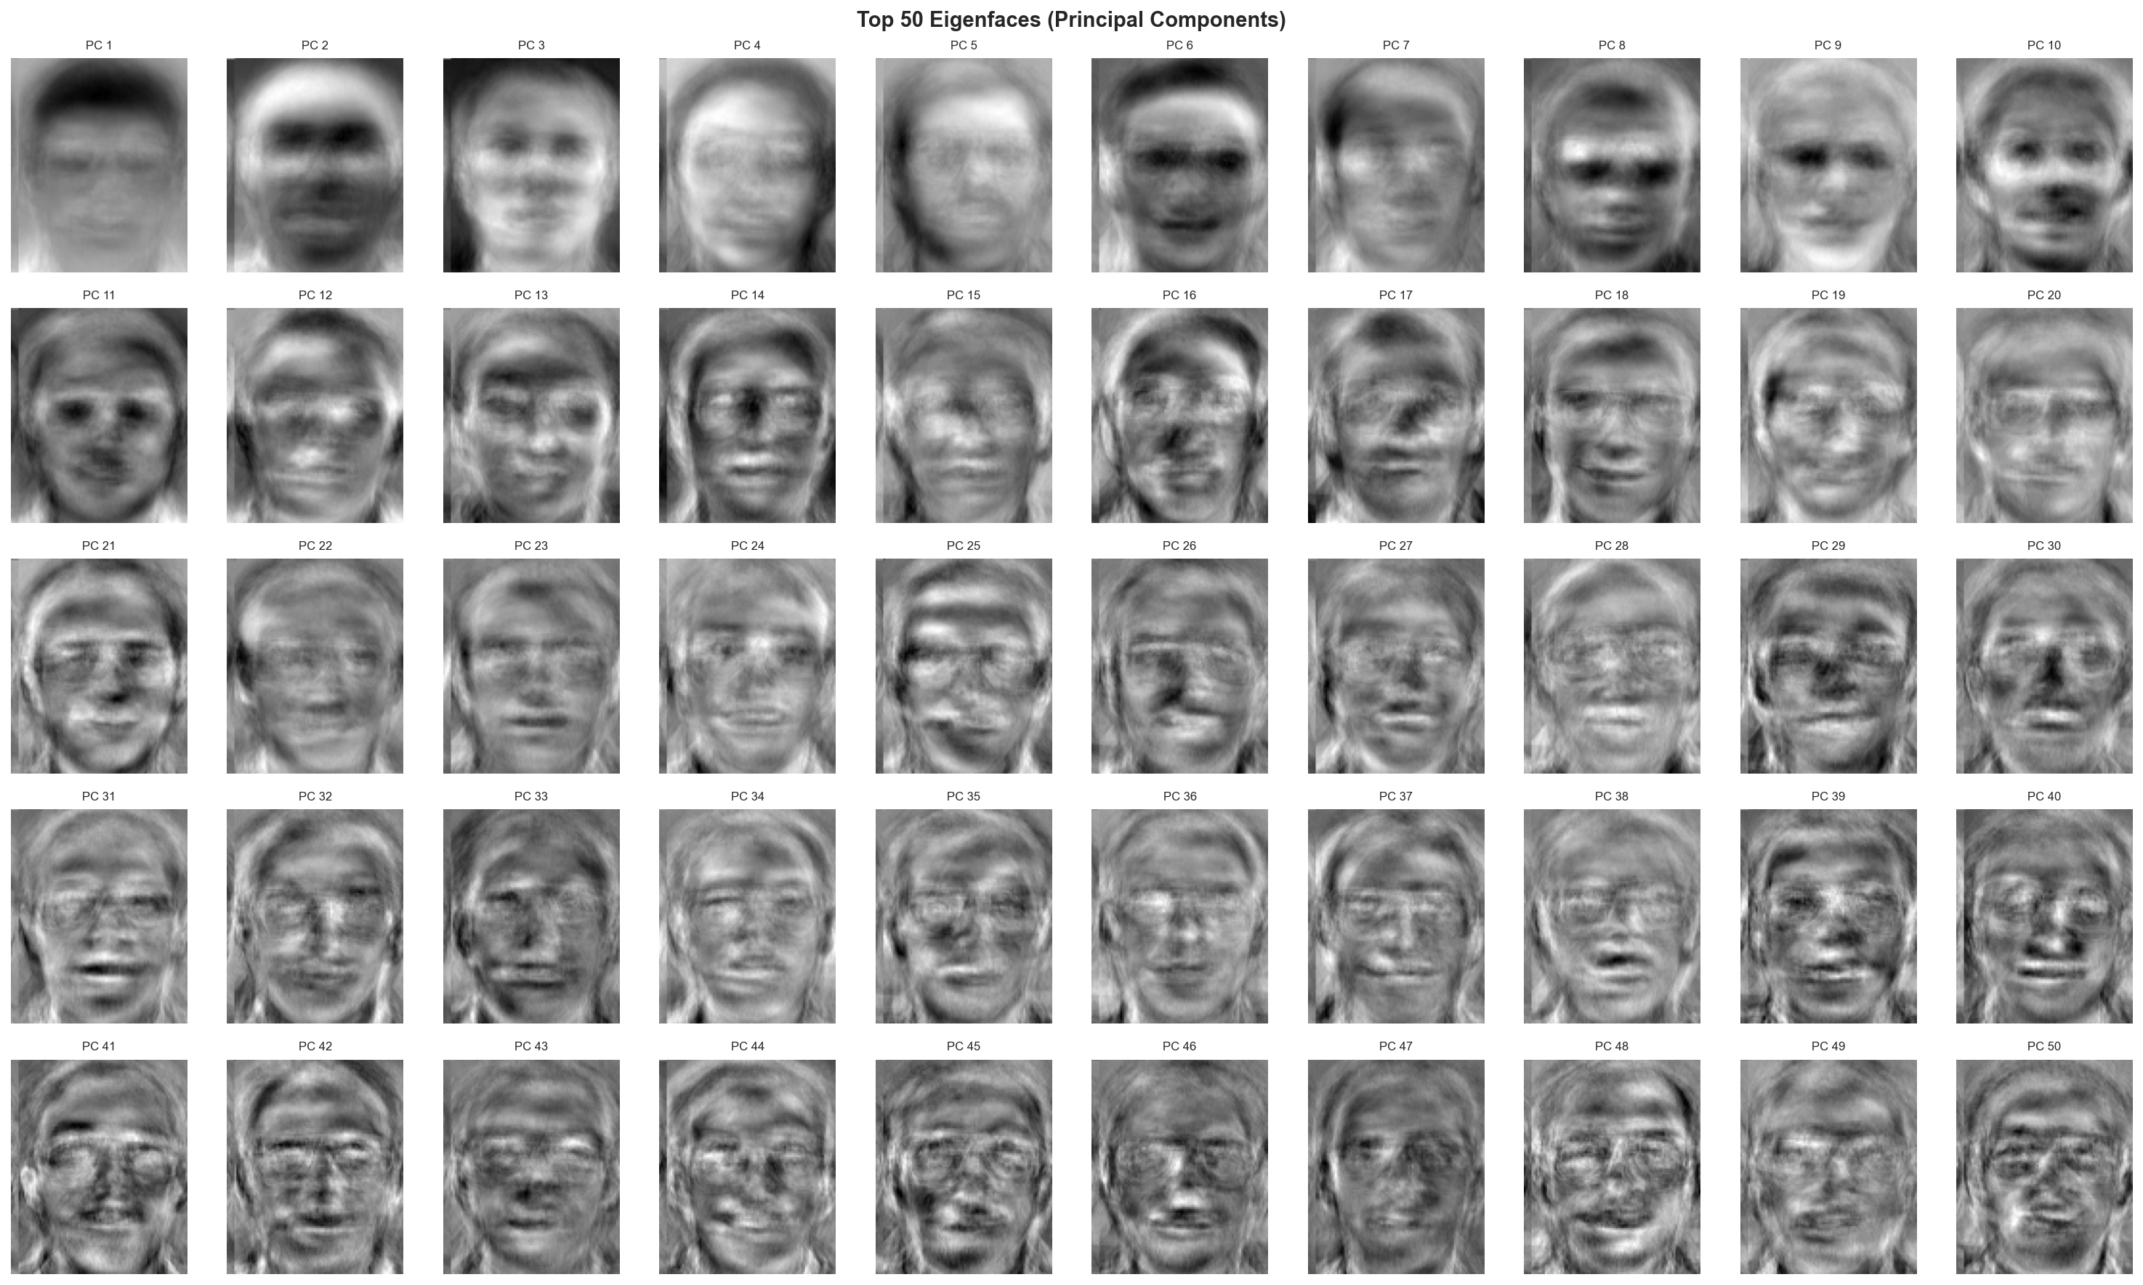
Figure 11: Top 50 eigenfaces ordered by decreasing eigenvalue magnitude.

3.2.3 Projection and Reconstruction
Images were projected onto the first 50 principal components and reconstructed by mapping back to the original pixel space and adding the mean face. Figure 12 compares original and reconstructed faces. The mean squared reconstruction error with 50 components was 285.75, indicating that significant structural information is captured even with a 200-fold dimensionality reduction (from 10,304 to 50 dimensions).
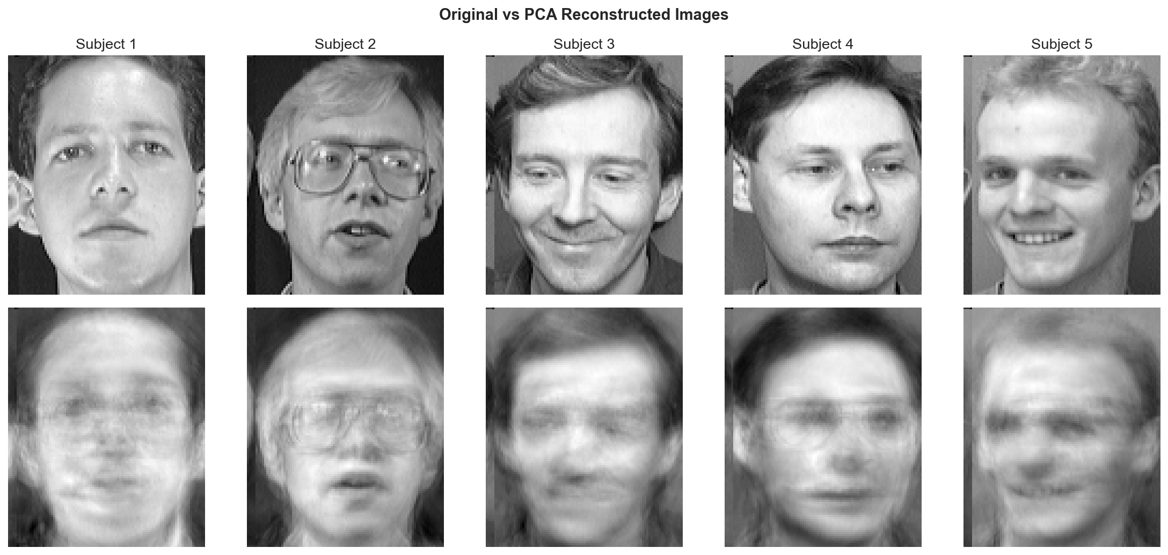
Figure 12: Original images (top row) versus reconstructions from 50 principal components (bottom row).

3.2.4 Variance Retention
The number of principal components required to retain given variance thresholds was determined: 111 components for 90%, 190 components for 95%, and 325 components for 99%. These results confirm that while the data admits substantial dimensionality reduction, the variance is distributed across many components, reflecting the high complexity and variability of face images.

3.2.5 Face Recognition in PCA Space
The dataset was split using a leave-one-out strategy (one image per subject for testing, nine for training), yielding 360 training and 40 testing samples. Two classifiers were evaluated in PCA space across varying numbers of principal components: a Nearest Centroid classifier and a Bayesian (Gaussian) classifier.
n_components | Nearest Centroid | Bayesian
10 | 0.9000 | 0.6750
20 | 0.9250 | 0.9500
30 | 0.9250 | 0.9750
50 | 0.9250 | 1.0000
75 | 0.9250 | 0.9750
100 | 0.9250 | 0.9750
150 | 0.9250 | 0.9750
200 | 0.9250 | 0.9750
Table 10: Classification accuracy in PCA space for varying numbers of components.
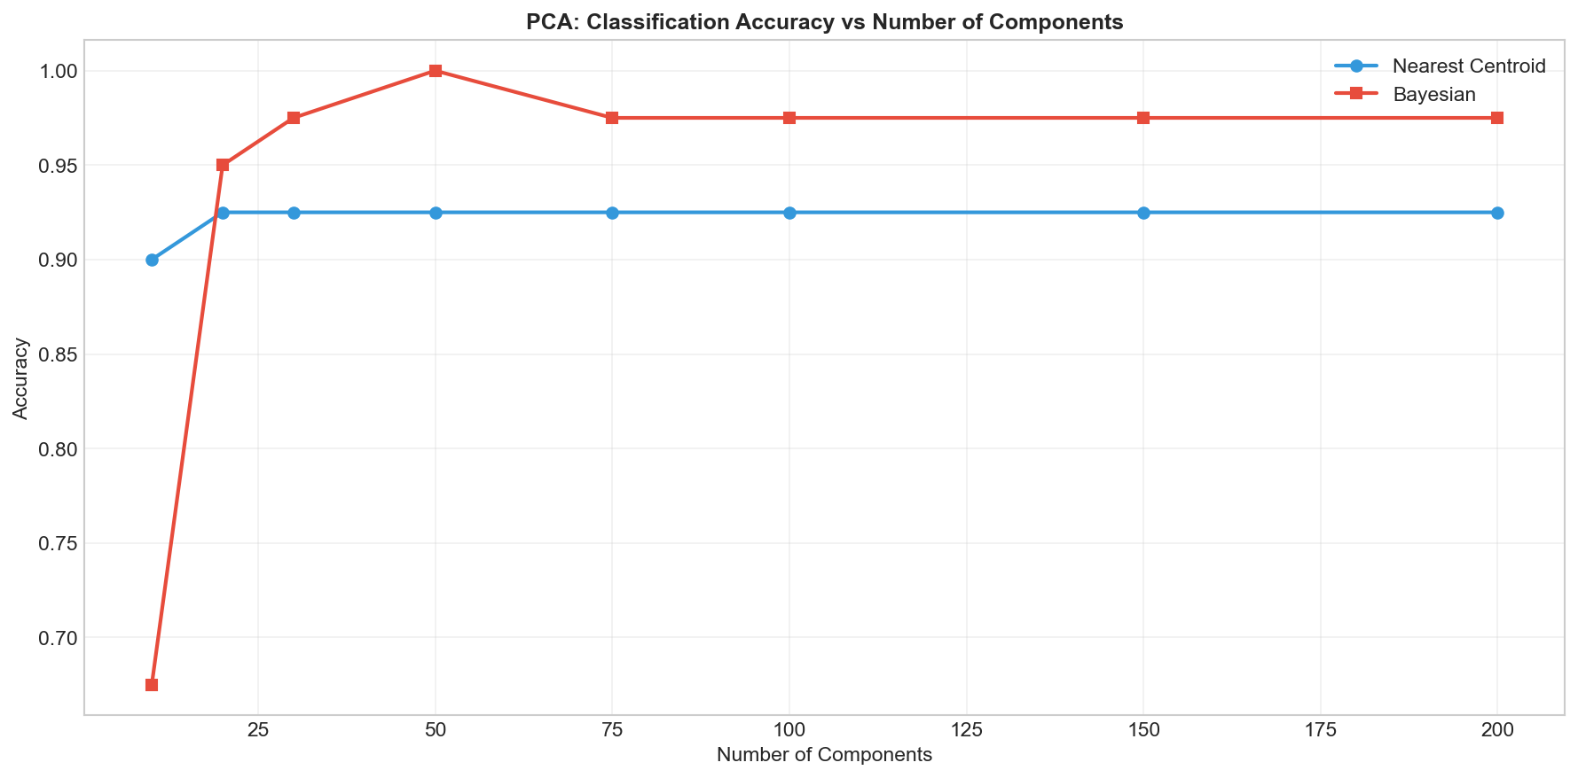
Figure 13: Classification accuracy versus number of PCA components.
The Nearest Centroid classifier saturates at 92.50% accuracy with as few as 20 components, exhibiting no further improvement with additional dimensions. In contrast, the Bayesian classifier achieves perfect accuracy (100%) at 50 components before slightly declining. The Bayesian classifier’s superior peak performance reflects its ability to model within-class covariance structure, which the centroid-based approach ignores. However, at very low dimensions (10 components), the Bayesian classifier underperforms (67.50%) due to insufficient dimensions for reliable covariance estimation across 40 classes.

3.2.6 PCA vs. PCA+LDA Comparison
To assess whether supervised dimensionality reduction provides additional benefit beyond PCA, a comparison was conducted between PCA-only and PCA followed by Fisher LDA. The Nearest Centroid classifier was used in both settings.
n_PCA | PCA Only | PCA + LDA
50 | 0.9250 | 0.9250
75 | 0.9250 | 0.9250
100 | 0.9250 | 0.9250
150 | 0.9250 | 0.9500
Table 11: PCA-only versus PCA+LDA recognition accuracy.
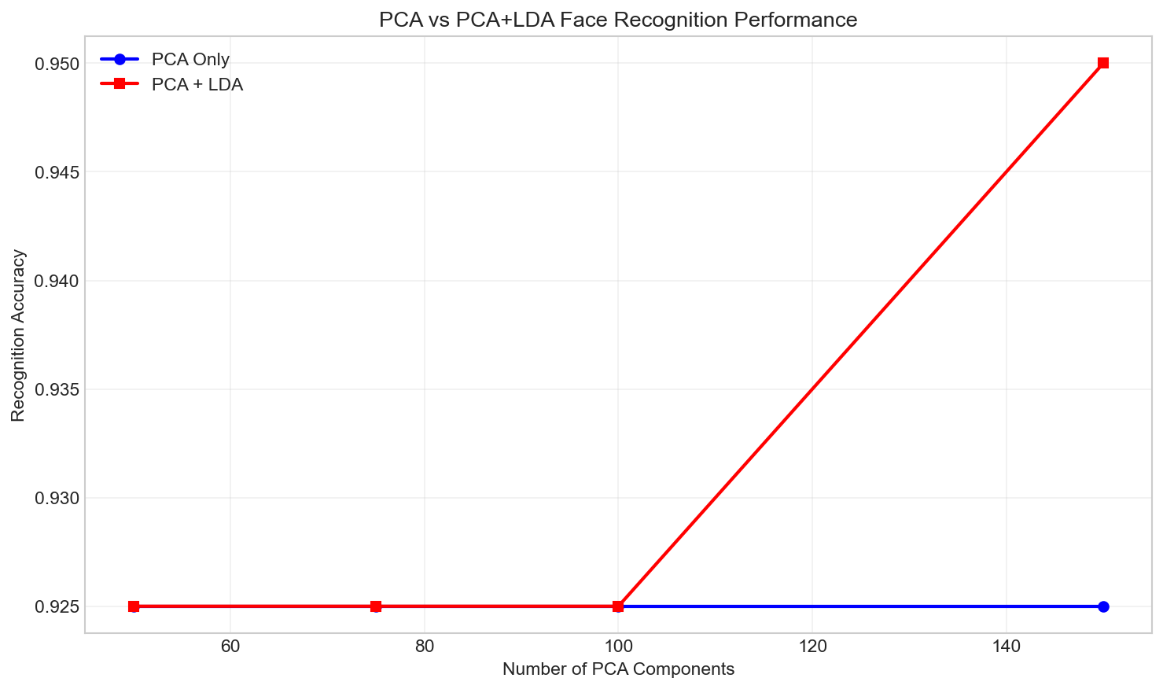
Figure 14: Comparison of PCA-only and PCA+LDA recognition performance.
The PCA+LDA pipeline shows marginal improvement only at 150 PCA components (95.0% vs. 92.5%), with equivalent performance at lower PCA dimensions. This result suggests that PCA already captures sufficient discriminative information for the Nearest Centroid classifier, and the additional supervised projection by LDA provides limited benefit in this experimental configuration.

3.3 Fisher Linear Discriminant Analysis

3.3.1 Data Preprocessing
Before applying Fisher LDA, dimensionality was first reduced from 10,304 to 100 via PCA. This preprocessing step is essential because the within-class scatter matrix S_{W} would be singular in the original 10,304-dimensional space (since the number of samples, 400, is far less than the dimensionality). Reducing to 100 dimensions ensures that S_W is invertible, enabling the solution of the generalized eigenvalue problem $SW^{-1}S_{B}v=λv$ . Whitening was not applied, as it is not mathematically required for Fisher LDA. The optimization criterion (maximizing the ratio of between-class to within-class scatter) is inherently scale-invariant, and whitening would merely precondition the scatter matrices without changing the resulting discriminant directions.

3.3.2 Scatter Matrices
The within-class scatter matrix S_{W} (100×100) captures the spread of data points around their respective class means, while the between-class scatter matrix S_{B} (100×100) captures the separation between class centroids relative to the global mean. S_{W} was found to have full rank (100) while S_{B} has rank 39, which equals the number of classes minus one (40 - 1 = 39). This rank constraint is fundamental: S_{B} is constructed from 40 outer products of class mean deviations, but these lie in a subspace of at most 39 dimensions (since the deviations sum to zero).

3.3.3 Eigenvalue Problem
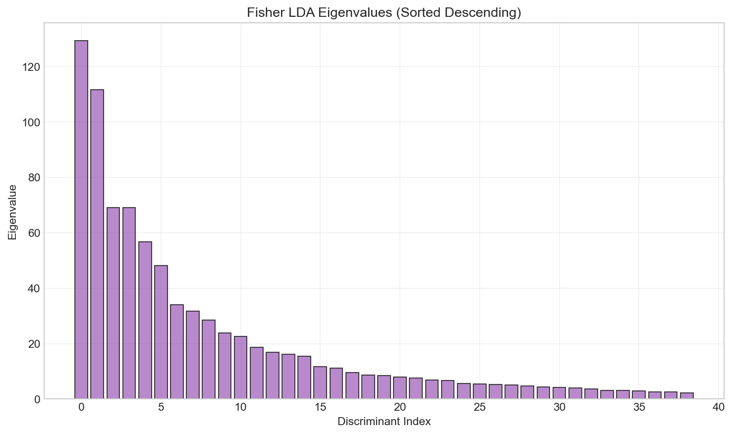
The generalized eigenvalue problem $SW^{-1}S_{B}v=λv$was solved, yielding 39 meaningful discriminant directions. The eigenvalues were sorted by absolute magnitude in descending order, as shown in Figure 15. The descending order is chosen because eigenvalues represent the ratio of between-class to within-class variance along each discriminant direction; larger eigenvalues correspond to directions of greater class separability.

Figure 15: LDA eigenvalues in descending order of magnitude.

3.3.4 Separability Analysis
The maximum number of discriminant components is constrained by $\text{min}\left(n_{\text{classes}}-1,n_{\text{features}}\right)=\text{min}\left(39,100\right)=39$ . Figure 16 shows how a cumulative separability metric evolves with the number of retained discriminants.
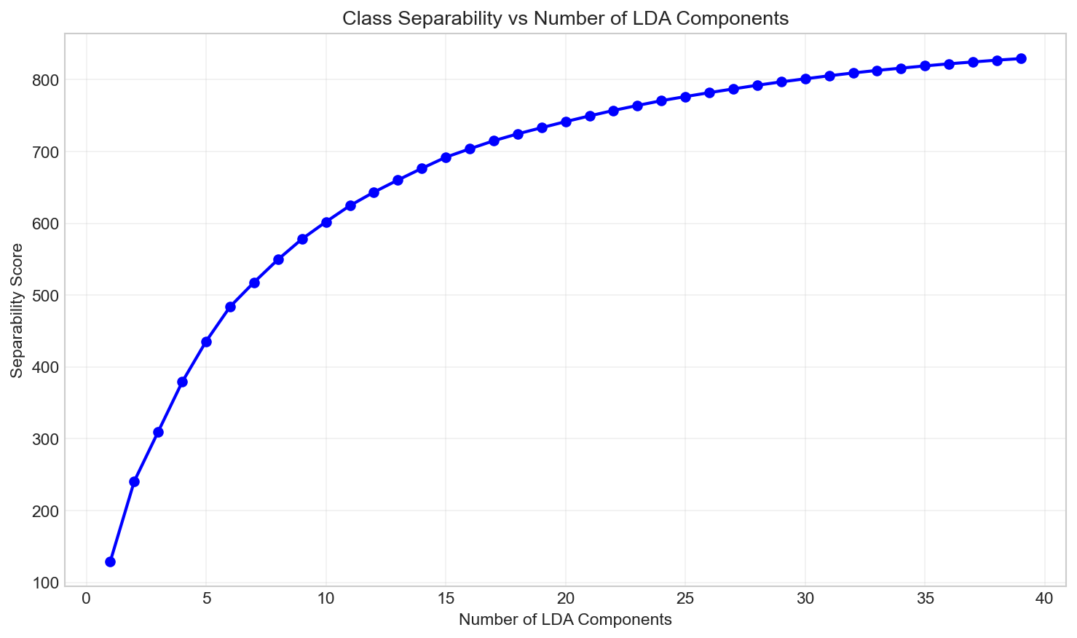
Figure 16: Cumulative separability metric as a function of retained LDA components.
The separability metric shows rapid initial growth followed by diminishing returns. Selecting too few components discards discriminative information, while retaining too many introduces noisy or weakly discriminative directions that can degrade classifier performance. The interplay between intra-class variability (pose, expression, illumination changes across images of the same subject) and inter-class differences determines the effective dimensionality of the discriminant subspace.

3.3.5 LDA Classification
Classification was evaluated across varying numbers of LDA components using the Nearest Centroid classifier. The results are presented in Table 12.

n_LDA | Accuracy
5 | 0.6000
10 | 0.8500
15 | 0.8750
20 | 0.8750
25 | 0.8500
30 | 0.8750
35 | 0.8500
Table 12: LDA classification accuracy versus number of discriminant components.
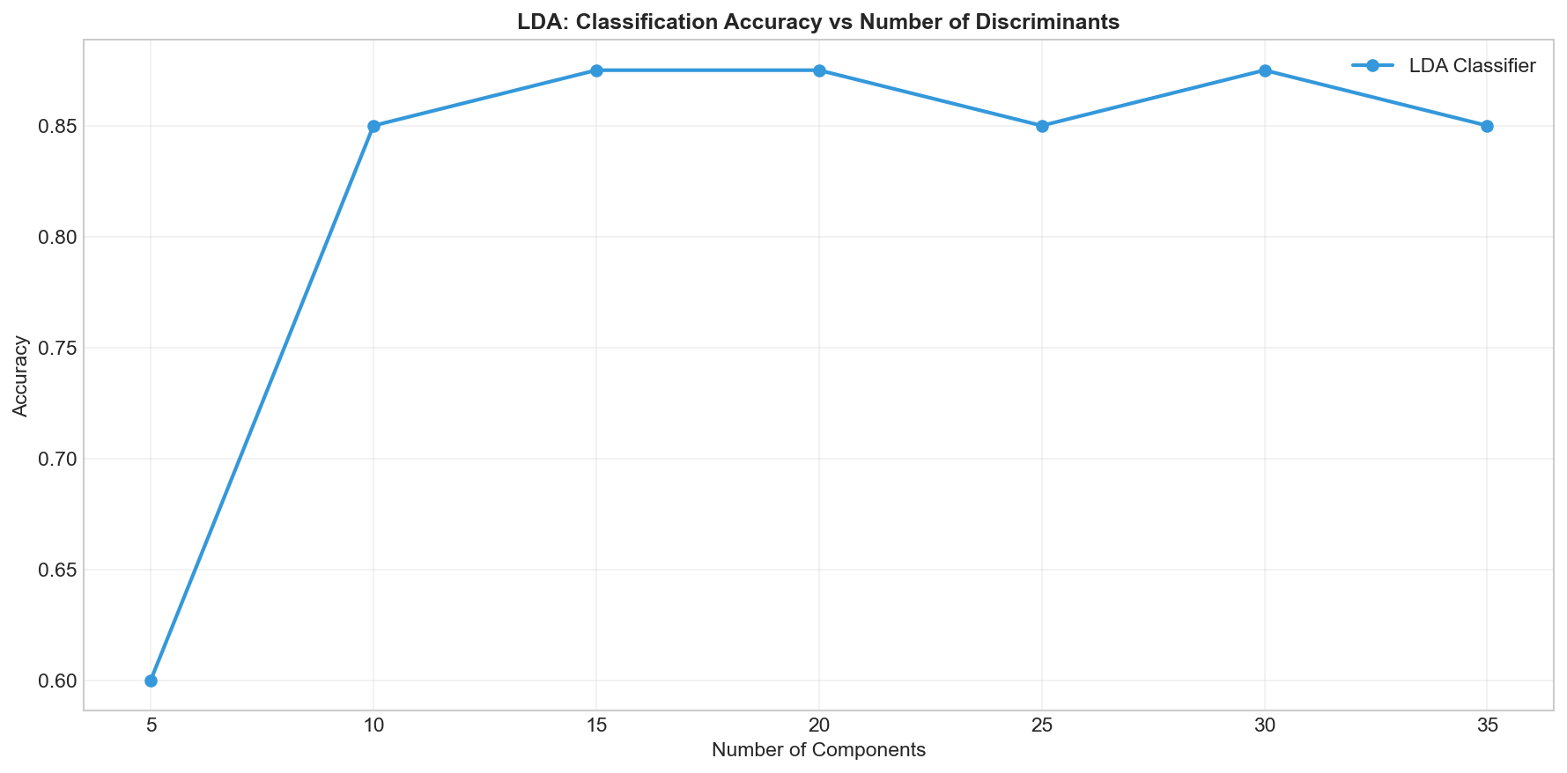
Figure 17: LDA classification accuracy versus number of discriminant components.
The best LDA-only accuracy of 87.50% is achieved at 15 components, after which performance oscillates without improvement. The diminishing returns analysis reveals a significant jump from 5 to 10 components (+25.0 percentage points), a marginal improvement from 10 to 15 (+2.5 points), and no systematic improvement thereafter. This pattern indicates that the first 10–15 discriminant directions capture the bulk of inter-class separability, while higher-order components introduce directions that do not contribute meaningful discriminative information and may instead introduce noise.
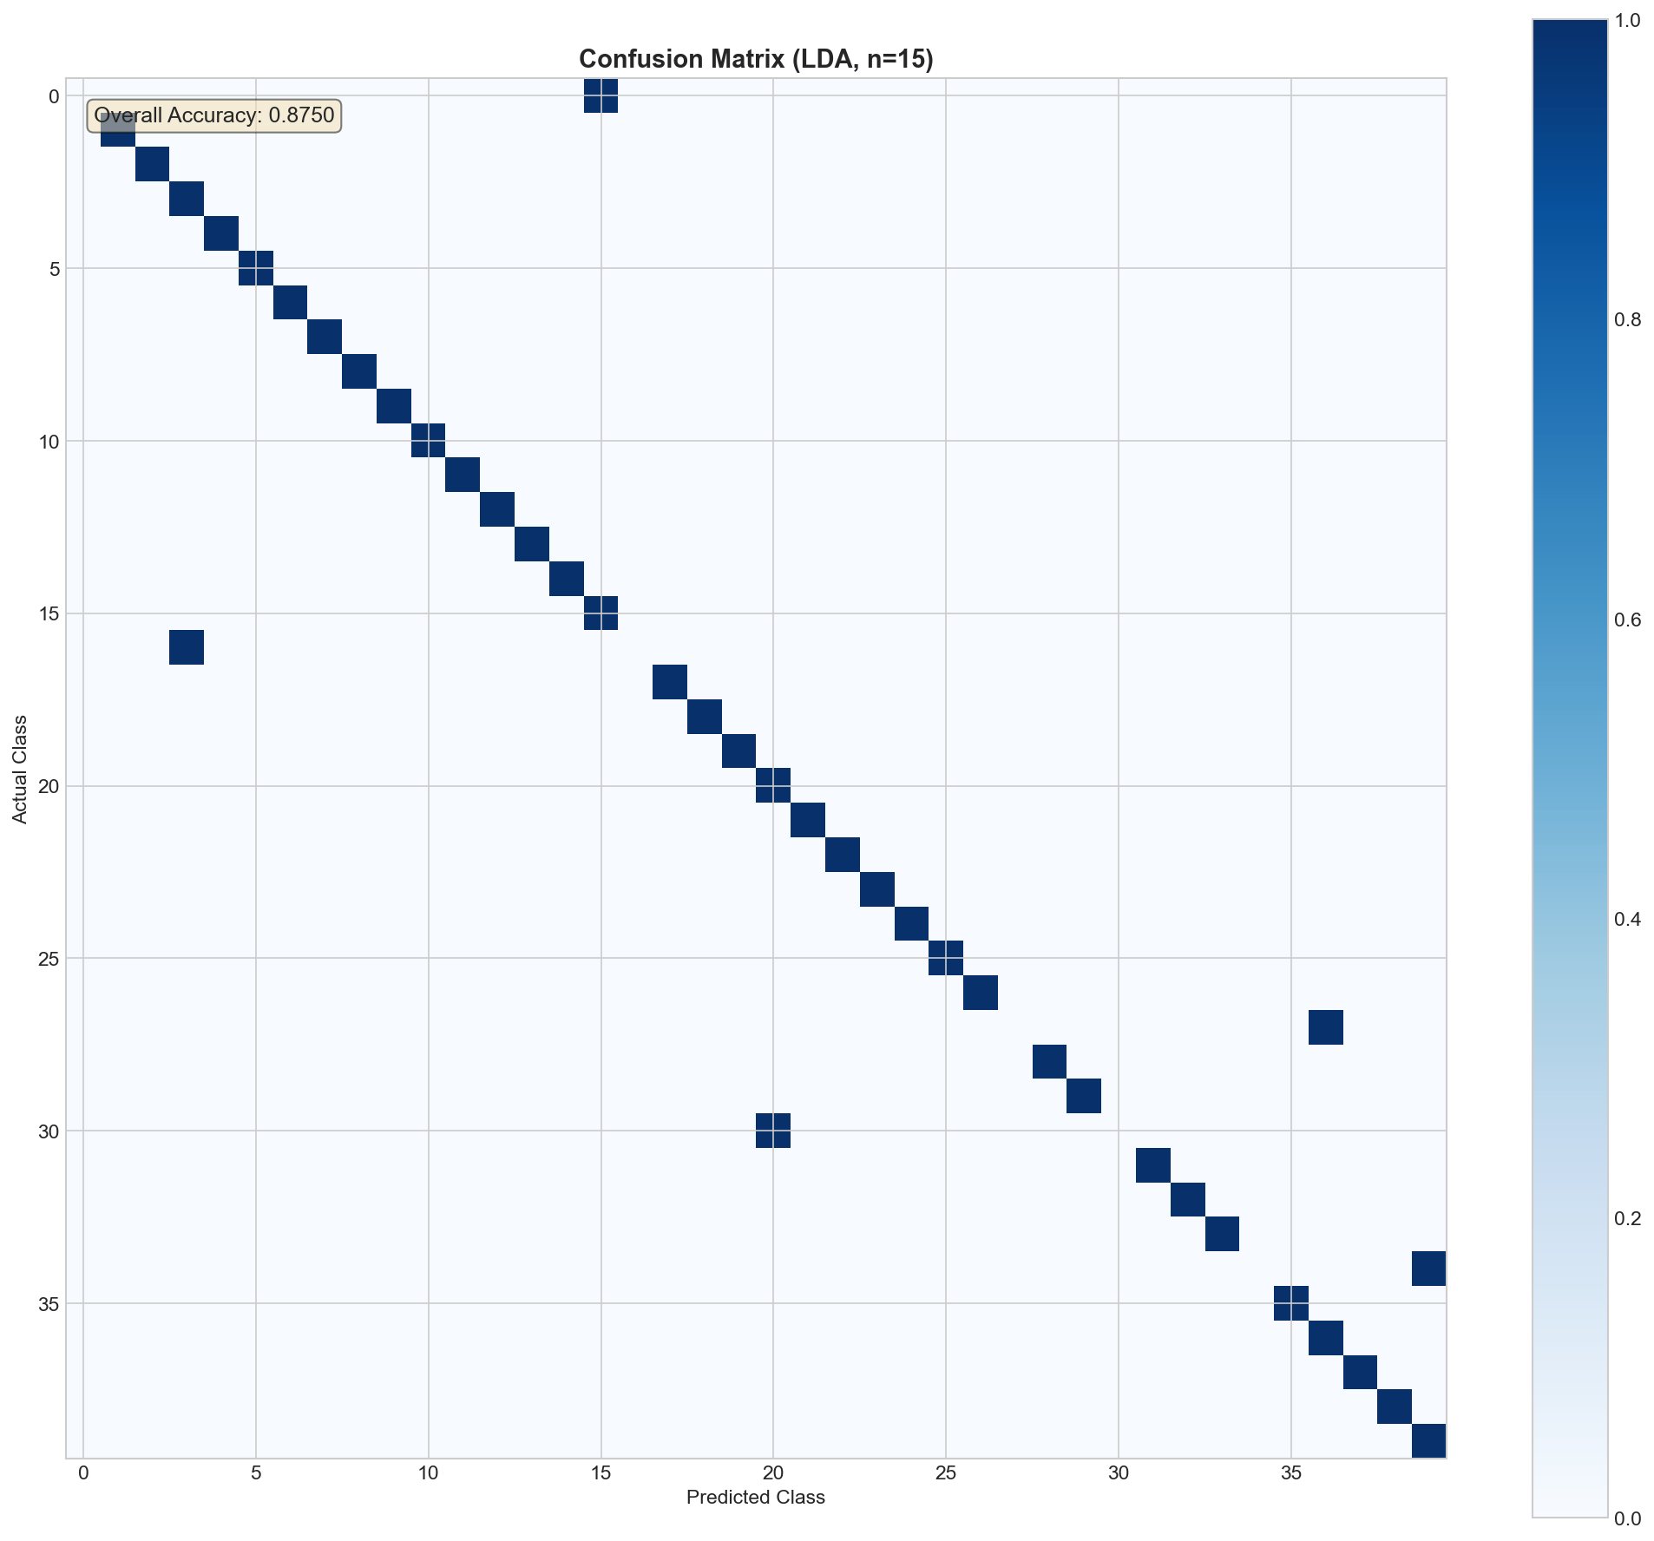
Figure 18: Confusion matrix for LDA classification with 15 discriminant components.

3.4 Comparative Summary
Method | Best Accuracy | Best Config.
PCA + Bayesian | 100.0% | 50 components
PCA + LDA + Centroid | 95.0% | 150 PCA dims
LDA-only + Centroid | 87.5% | 15 components
Table 13: Summary of best face recognition performance across methods.
PCA combined with a Bayesian classifier achieves the highest recognition accuracy (100%) at 50 components, demonstrating that an appropriate probabilistic classifier can fully exploit the variance-preserving subspace learned by PCA. The PCA+LDA pipeline provides moderate improvement over PCA alone but does not surpass the Bayesian approach. The LDA-only approach yields the lowest accuracy (87.5%), likely because the PCA preprocessing for LDA (reducing to 100 dimensions before LDA) represents a more aggressive bottleneck and the Nearest Centroid classifier is less powerful than the Bayesian alternative.

4. Conclusion
This report investigated Bayesian classification and dimensionality reduction through rigorous implementation and analysis. In the binary classification task on the Breast Cancer Wisconsin dataset, LDA and QDA achieved identical test accuracies of 93.81%, outperforming Gaussian Naive Bayes (91.15%). The conditional independence assumption of GNB was shown to be a meaningful limitation in the presence of strongly correlated features. Covariance matrix analysis revealed severe ill-conditioning (condition number of 6.18×10¹¹) despite full rank, underscoring the critical distinction between mathematical non-singularity and numerical stability. Variance-based feature elimination provided modest improvement in conditioning but was insufficient as a standalone remedy.
For the face recognition task on the ORL database, PCA combined with a Bayesian classifier achieved perfect recognition accuracy with only 50 principal components out of 10,304 original dimensions. Fisher LDA provided effective supervised dimensionality reduction, with the optimal number of discriminant components (15) being significantly fewer than the theoretical maximum (39), reflecting diminishing returns in discriminative power beyond the leading eigenspace. The comparison between PCA-only and PCA+LDA approaches demonstrated that the choice of classifier is at least as important as the dimensionality reduction strategy.
Key insights from this work include: the importance of regularization for covariance estimation in moderate-dimensional settings, the inadequacy of variance as a proxy for discriminative relevance in feature selection, the computational advantage of the PCA kernel trick for high-dimensional data, and the fundamental trade-off between model complexity and data availability that governs the relative performance of LDA versus QDA.

